Ayush Goyal
190905522 CSE D Roll 62

Compiler Design Lab 1

Write a C program to :

1. To count the number of lines and characters in a file.

Code:

#include <stdio.h>
#include <stdlib.h>
#include <strings.h>

int main(){
int countline=0,countc=0;
char c;FILE *fptr;
fptr= fopen("input.txt","r");
if(!fptr){
printf("Cannot open file\n");
exit(0);
}
c=getc(fptr);
while(c!=EOF){
if(c=='\n') countline++;
/*Assuming that whitespace and new line are not considered as characters*/
else countc++;

c=getc(fptr);
}
if(countc >0) countline++;
printf("Total number of lines and characters is %d and %d respectively\n",countline,countc);
return 0;
}

We also create an “input.txt” file for testing and the following along with the output is shown as following:

Output:

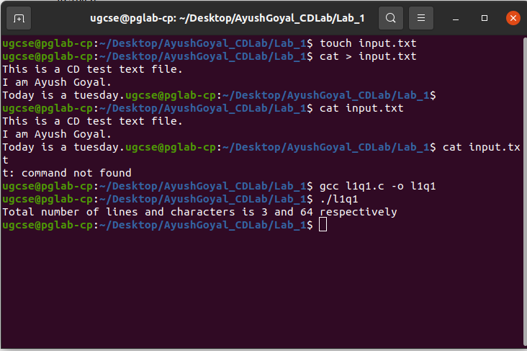

2. To reverse the file contents and store in another file. Also display the size of file using file handling function.

Code:

#include <stdio.h>
#include <stdlib.h>
#include <strings.h>
#include <sys/stat.h>

int main(){
FILE *fa,*fb;
char ch,buffer[1024];
int i=0;
fa=fopen("input.txt","r");
fb=fopen("output.txt","w+");
if(!fa||!fb){
printf("Cannot open the file");
exit(1);
}
while(ch!=EOF){
ch=getc(fa);
buffer[i++]=ch;
}
for(int j=(i-2);j>=0;j--){
ch=buffer[j];
fputc(ch,fb);
}
fseek(fa,0,SEEK_END);
int size=ftell(fa);
printf("File size is : %d\n",size );
}
We create an output.txt file and run the following commands to carry out the operations required:

Output:

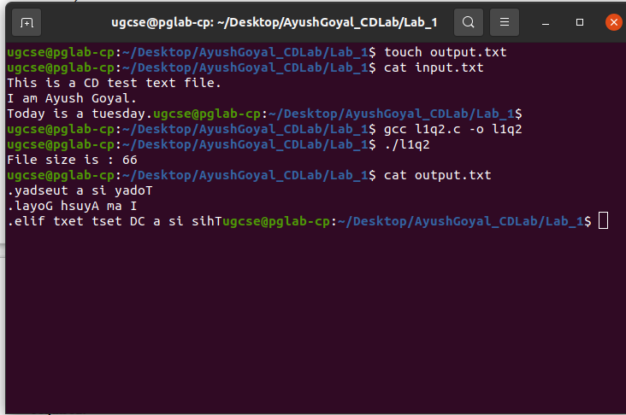

3. That merges lines alternatively from 2 files and stores it in a resultant file.

Code:

#include <stdio.h>
#include <stdlib.h>
#include <strings.h>
#include <sys/stat.h>

int main(){
FILE *f1,*f2,*f3;
char c1,c2;
f1=fopen("file1.txt","r");
f2=fopen("file2.txt","r");
f3=fopen("output.txt","w+");
if(!f1||!f2||!f3){
printf("Cannot open file\n");
exit(1);
}
while(1){
if(c1!=EOF){
c1=fgetc(f1);
while(c1!='\n'){
if(c1==EOF) break;
fputc(c1,f3);
c1=fgetc(f1);
}
fputc('\n',f3);
}
if(c2!=EOF){
c2=fgetc(f2);
while(c2!='\n'){
if(c2==EOF) break;
fputc(c2,f3);
c2=fgetc(f2);
}
fputc('\n',f3);
}
if(c1==EOF && c2==EOF) break;
}
return 0;
}

We create two files with sensible texts, namely file1.txt and file2.txt. Then we compile and run our C program and see the required operation in the file output.txt :

Output :

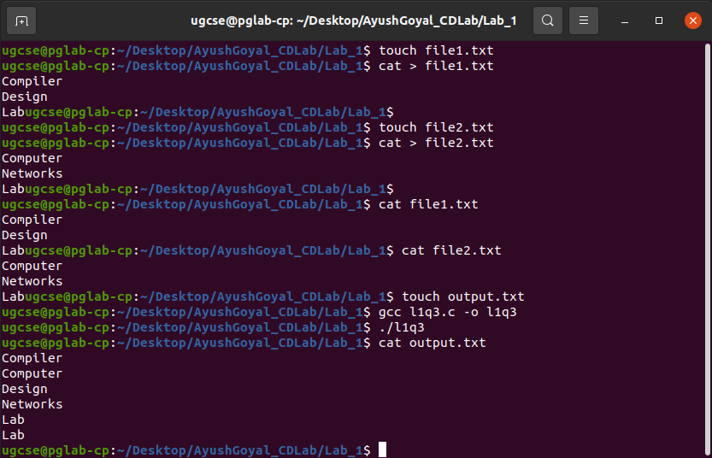
THE END

